

**NEWS RELEASE   
*Editor’s note: High-res photos available upon request***

Media Contact:  
Carolyn Schinsky / Ryan PR / 314-822-9784/ [carolyn@ryan-pr.com](mailto:carolyn@ryan-pr.com)

**Insulation Opportunity Spurs Purchase of**

**Touch ‘n Seal’s Portable Spray Foam System**

***Constant Pressure Dispensing System Provides Affordable Alternative to Costly Spray Foam Dispensing Trucks***

**[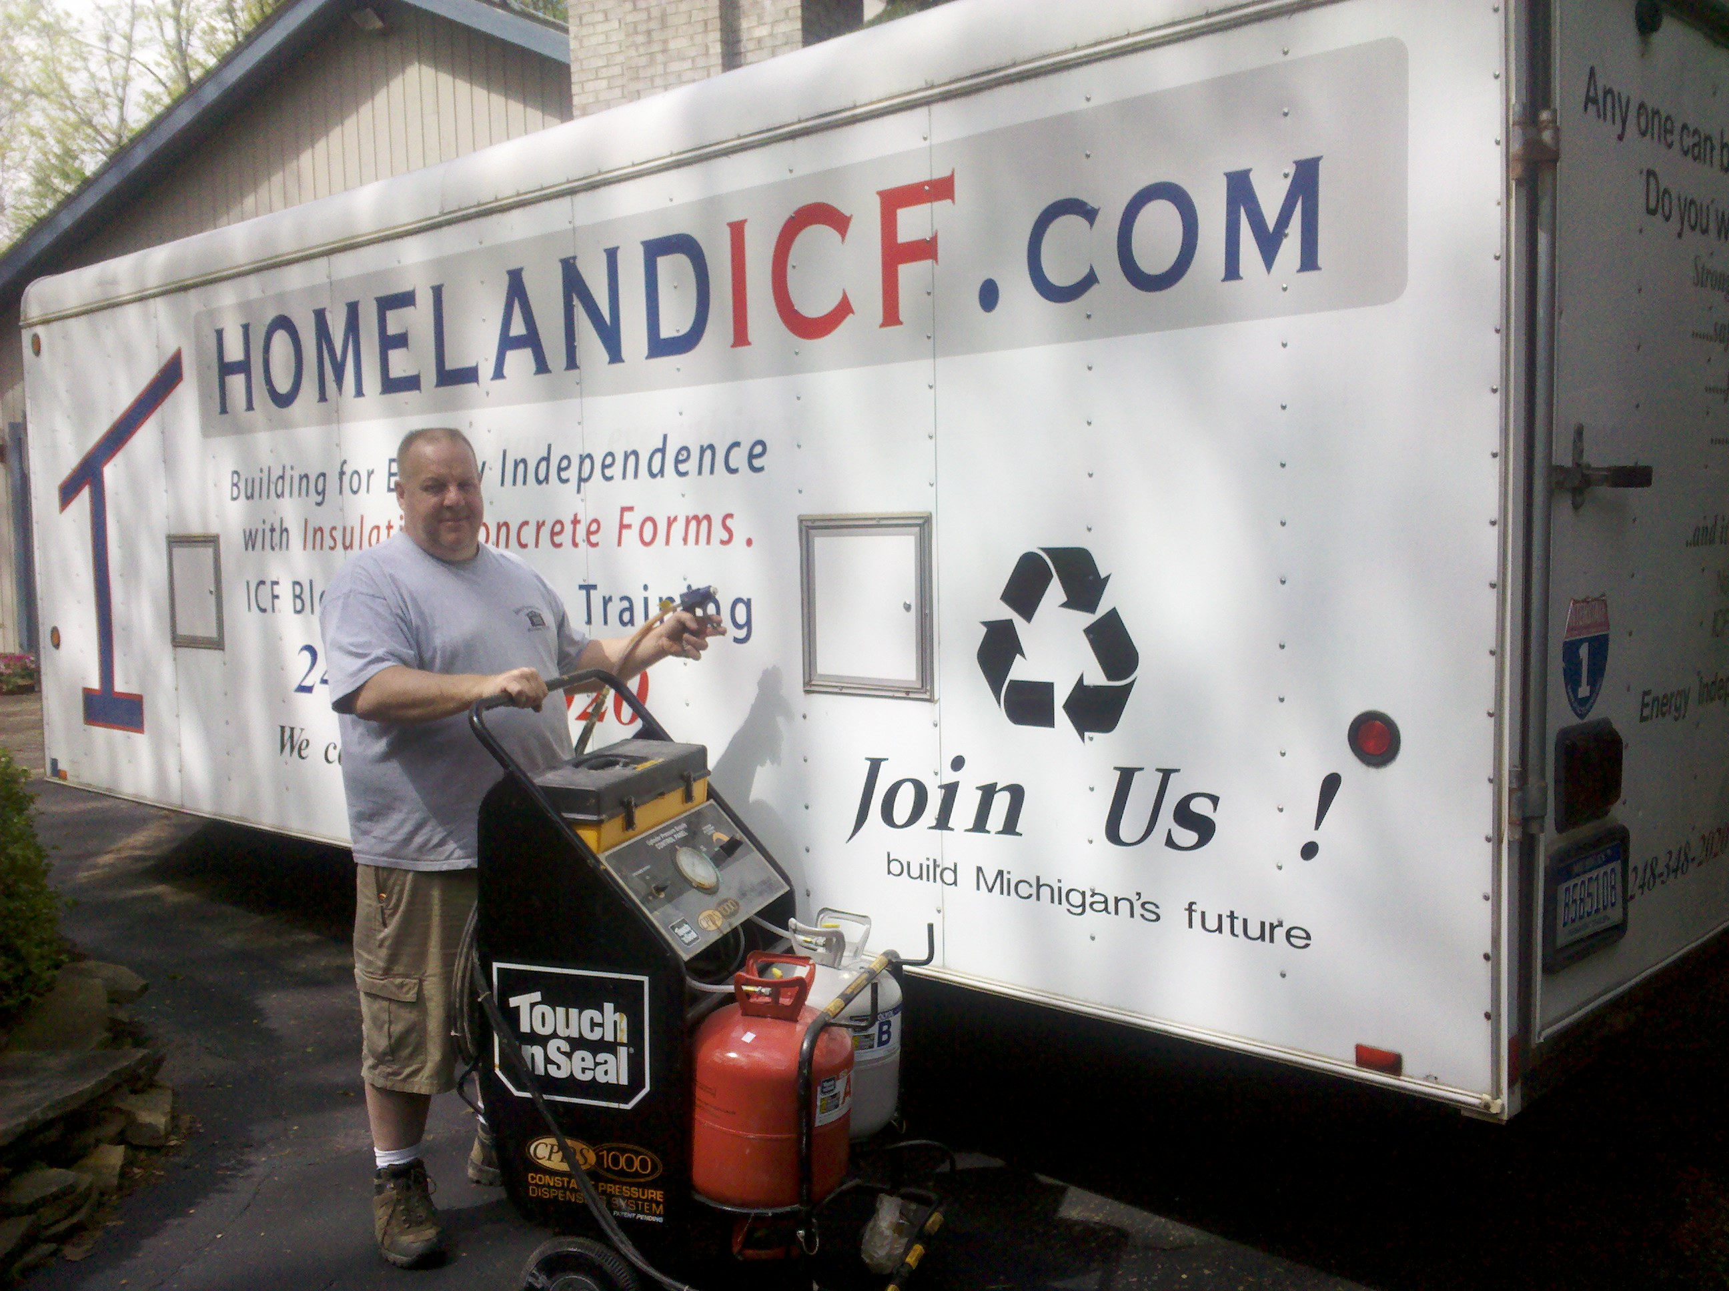](http://www.touch-n-seal.com)**

***Pictured: Bud Youngs, insulation specialist at Homeland Builders of Michigan***

ST. LOUIS—Oct. 31, 2011— When an opportunity to do a townhouse cooperative insulation project came knocking on the door at [Homeland Builders of Michigan](http://www.homelandbuildersgroup.com/homeland.htm) it also presented a problem. The company couldn’t afford to lease a costly spray foam dispensing truck; they not only needed an affordable alternative but one that would also allow them to complete the project on time. Homeland Builders turned to [Touch ‘n Seal’s Constant Pressure Dispensing System](http://www.touch-n-seal.com/constantpressuresprayfoam.htm) (CPDS), a self-contained, portable, spray foam system that dispenses Class I fire retardant, thermal insulating 2-component [polyurethane spray foam](http://www.touch-n-seal.com) – twice as fast as foam kits.

Homeland Builder’s opportunity with the townhouse cooperative involved insulating more than 300 townhome entryways with spray foam insulation. However, the co-op contract stated that each entryway had to be insulated and sealed up in the same day, which would only allow for the completion of ten entryways per day. When Bud Youngs, an insulation specialist at Homeland Builders, approached several companies about leasing a foam truck, each company told him that Homeland would need to pay for the time the truck was on-site, whether in use or not. The cost to pay for the truck’s downtime far exceeded Homeland’s budget. Youngs was under the gun to find an affordable alternative to leasing a dispensing truck.

[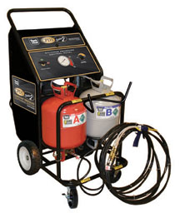](http://www.touch-n-seal.com/assets/cpdsvideo/constantpressuresprayfoam_video_1.htm)Youngs had recently been eyeing a new piece of spray foam equipment, Touch ‘n Seal’s CPDS. He was impressed by the idea that the unit would enable him to complete jobs quickly and eliminate the need to lease expensive spray foam dispensing trucks. The townhome project triggered him into action. He purchased the CPDS from EFI, his local distributor, watched an informational video on how to use the unit, and began using the CPDS to spray foam the entryways the next day.

Youngs was pleased with the results. Using the CPDS his team easily completed ten entryways per day, using 33 disposable foam cylinders. “The CPDS was perfect for this project. The unit was easy to transport to the job site and at the end of each day we just stored it in a garage till the next day of use,” says Youngs. “The CPDS allowed us to complete the project in a fast and economical manner.”

Using an adjustable constant delivery rate, the CPDS operator can easily apply spray foam to horizontal or vertical surfaces. Hoses up to 150’ long allow for jobsite portability and versatility. With an empty weight of less than 155 lbs., and a 24” x 33” footprint, the CPDS fits in the back of a standard pick-up truck and easily navigates through standard doorways and entrances.

Homeland Builders of Michigan plans to expand their business by using the CPDS to insulate areas like crawl spaces, rim joist and hot roofs. “Before we bought the CPDS, we’d either refer these types of insulation projects to someone else and lose the business, or resort to hiring a foam dispensing truck,” says Youngs. “Today we can get insulation projects done on our own and make money without having to lease expensive equipment.”

Homeland Builder’s upcoming projects include insulating the underside of a roof, a residential crawl space and a pole barn. “Owning the CPDS unit has given us the chance to take advantage of profitable spray foam insulating business opportunities like this,” says Youngs. “The CPDS is a great solution for any contractor or builder interested in expanding their business.”

For more information, contact Touch ‘n Seal Customer Service at 800-325-6180, or visit [www.touch-n-seal.com](http://www.touch-n-seal.com). To view a video on how CPDS Series 2 Constant Pressure Dispensing System operates, visit <http://www.touch-n-seal.com/assets/cpdsvideo/constantpressuresprayfoam_video_1.htm>.

For more information on Homeland Builders of Michigan call 734-476-4116 or visit <http://www.homelandbuildersgroup.com/homeland.htm>

# # #

About Touch ‘n Seal

Convenience Products, the manufacturer of Touch ‘n Seal products, is headquartered in St. Louis, Missouri Touch ‘n Seal insulating foams and sealants are the benchmark for performance in commercial and industrial building and maintenance, OEM manufacturing and specialty applications. A full line of one and two-component spray foams and adhesives are available, including fire blocking foam  (ICC-ES: ESR-1926), marine foam, low pressure window & door foam, roof tile adhesives, drywall panel adhesives, heating systems and accessories, two-component disposable units, mining Specialty units and one-component disposable cylinders. Spray foam is available from 15-board feet kits to 120-gallon refill systems.  One-component straw and gun foam available in 12 to 30.5 oz. aerosol cans. For more information, visit [http://www.touch-n-seal.com](http://www.touch-n-seal.com/).