NEWS RELEASE
Editor’s note: Hi-res photos available upon request

Media Contact:
Carolyn Schinsky / Ryan PR / 314-822-9784/ carolyn@ryan-pr.com

Touch ‘n Seal Introduces New Long Barrel Spray Foam Applicators
Applicators Provides Extended Reach for Low and High Areas

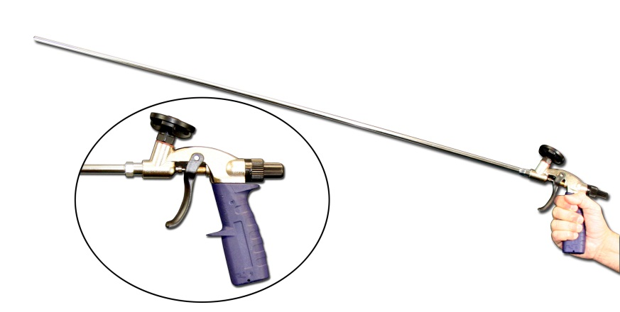

ST. LOUIS—Jan. xx, 2012— Convenience Products, the manufacturer of Touch ‘n Seal insulating foams, sealants and specialty products, has added two new Long Barrel Spray Foam Applicators to their product lineup. Designed for the application of single component gun foam, the reusable applicators are available in 39” and 46” lengths. Both applicators feature steel barrels, adjustable outputs to control product flow and comfort grip handles.

“Users can easily reach high and low areas with the extra-long barrels on Touch ‘n Seal’s new applicators,” says Michael Sites, Industrial Building Materials Marketing Manager at Touch ‘n Seal. “Elevated areas like rim joists can be reached without a ladder and low areas like sill plates can be reached without bending over. The new applicators reduce operator fatigue and increase applicator safety by eliminating the need for ladders in many hard-to-reach areas.”

Touch ‘n Seal’s Long Barrel Applicator adjustable output nozzle ensures a precise and economical application of foam. After use, the long steel barrels can be easily cleaned with Touch ‘n Seal Poly-Clean, an EPA zero VOC polyurethane foam cleaner.

For more information, visit http://www.touch-n-seal.com. To locate a local distributor contact Touch ‘n Seal customer service at 800-325-6180.

# # #
About Touch ‘n Seal
Convenience Products, the manufacturer of Touch ‘n Seal products, is headquartered in St. Louis, Missouri. Touch ‘n Seal Insulating Foams and Sealants are the benchmark for performance in Commercial and Industrial Building and Maintenance, OEM Manufacturing and Specialty applications. A full line of one and two-component spray foams and adhesives are available, including Fire Blocking Foam (ICC-ES: ESR-1926), Marine Foam, Low Pressure Window &Door Foam, Roof Tile Adhesive, Drywall Panel Adhesives, Foam Heating Systems and Accessories, two-component disposable kits, Mining Specialty kits and one-component disposable cylinders. Spray foam is available from 15-board feet kits to 120-gallon refill systems. One-component straw and gun foam is available in 12 to 30.5 oz. aerosol cans. For more information, visit http://www.touch-n-seal.com.

