NEWS RELEASE
Note: Hi-resolution photo available upon request
Contact Information:
Carolyn Schinsky / Ryan PR / 314-822-9784/ carolyn@ryan-pr.com

Touch ‘n Seal Spray Foam Insulation Passes
NFPA 286 (2011 Edition) Room Corner Fire Test
Foam is Code Approved for Exposed Roof/Wall Junctures

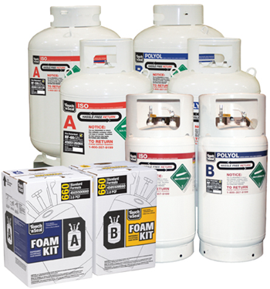
Touch 'n Seal Insulating Spray Foam Meets NFPA 286 Criteria

ST. LOUIS—Dec. 16, 2011— Convenience Products, the manufacturer of Touch ‘n Seal Insulating Foams and Sealants for new construction and retrofit applications, announces its Class 1, FR 1.0, 1.75 and 2.0 lb. spray foam insulation has passed the NFPA 286 (2011 Edition) room corner fire test. It also meets the requirements set forth in the 2006 IBC section 803.21/2009 IBC Section 803.1.2, which eliminates the need for a thermal or ignition barrier. The code approved, two-component polyurethane foam can be left exposed in non-fire-resistant roof/wall junctures at a maximum of 6” high and 2” deep with unlimited length.

“Insulating exposed roof/wall junctures with spray foam insulation is easier and faster than chinking these areas with batt insulation,” states Michael Sites, Touch ‘n Seal Marketing Manager. “Insulating with foam also enhances a building’s energy efficiency and occupant comfort. When spray foam is applied it expands to create an airtight seal, controlling conditioned air from escaping and unconditioned air from entering. Air leakage can account for up to 40% of energy loss.”

Touch ‘n Seal’s two-component Class 1 Fire Retardant Spray Foam is available in disposable chemical cylinders and 17-, 60- and 120-gallon refill systems. The portable refill system provides quick and easy foam application for repairs, renovations, new installations and production applications.

For more information, visit http://www.touch-n-seal.com or contact Touch ‘n Seal customer service at 800-325-6180.

# # #

About Touch ‘n Seal
Convenience Products, the manufacturer of Touch ‘n Seal products, is headquartered in St. Louis, Missouri. Touch ‘n Seal Insulating Foams and Sealants are the benchmark for performance in Commercial and Industrial Building and Maintenance, OEM Manufacturing and Specialty applications. A full line of one and two-component spray foams and adhesives are available, including Fire Blocking Foam (ICC-ES: ESR-1926), Marine Foam, Low Pressure Window & Door foam, Roof Tile Adhesive, Drywall Panel Adhesives, Foam Heating Systems and Accessories, two-component disposable kits, Mining Specialty kits and one-component disposable cylinders. Spray foam is available from 15-board feet kits to 120-gallon refill systems. One-component straw and gun foam is available in 12 to 30.5 oz. aerosol cans. For more information, visit www.touch-n-seal.com.

