NEWS RELEASE
Note: Hi-resolution images available upon request

Contact Information:
Carolyn Schinsky / Ryan PR / 314-822-9784/ carolyn@ryan-pr.com

Carolina Aire & Mold Solutions Achieves Success with
Touch ‘n Seal’s Constant Pressure Portable Spray Foam System
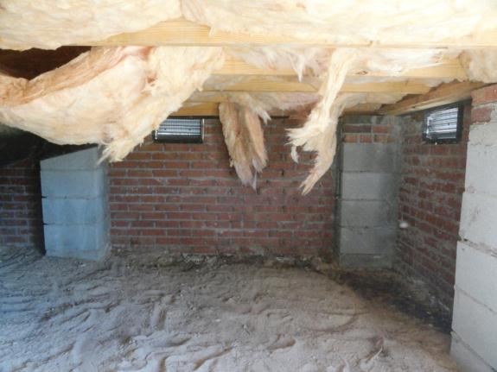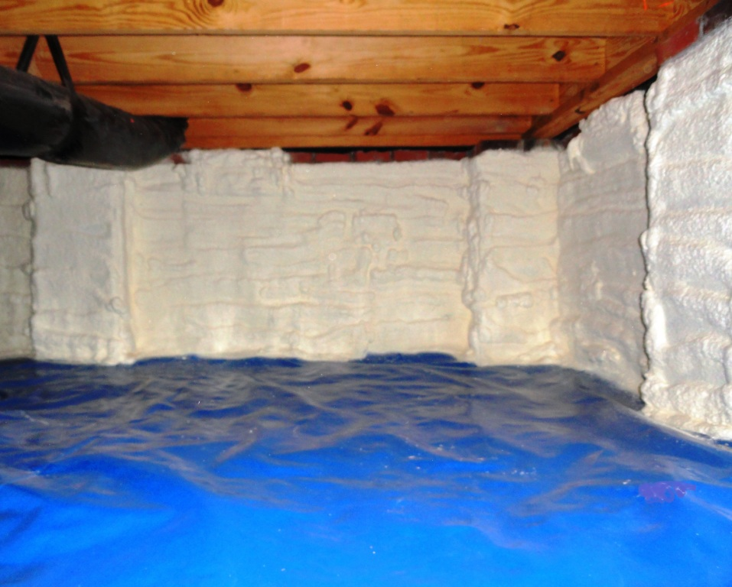
Crawl space before and after spray foam insulation - Photos courtesy of Carolina Aire & Mold Solutions

ST. LOUIS—May 22, 2012—It’s been said that to operate a successful business, you must find a need and fill it. That’s exactly what business owner Joel Few of Carolina Aire & Mold Solutions did when he purchased Touch ‘n Seal’s Constant Pressure Spray Foam System (CPDS) to expand his air quality and mold solutions business that had been crippled by the country’s economic downturn.

Aware of an increasing demand for spray foam insulation in the South Carolina market his business serves, Few credits his decision to purchase the CPDS portable spray foam unit as a rags-to-riches story. “I’d heard how other people had used the CPDS to expand their businesses. I wanted to make a good, honest living and decided purchasing a unit would give me the opportunity to do so without a large investment cost,” says Few. “I also liked the idea of helping people save money on their energy bills and improving the comfort of their homes by air sealing with spray foam.”
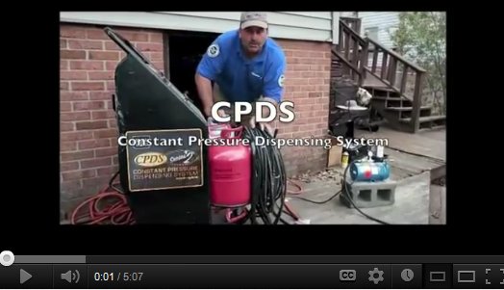
A self-contained, portable spray foam system, the CPDS dispenses Class I fire retardant, thermal insulating and sound attenuating 2-component polyurethane spray foam – twice as fast as foam kits. Using an adjustable constant delivery rate, the CPDS operator can apply spray foam to horizontal and vertical surfaces. Hoses up to 150’ long allow for jobsite portability and versatility. With an empty weight of less than 155 lbs., and a 24” x 33” footprint, the CPDS fits in the back of a standard pick-up truck and easily navigates through standard doorways and entrances.
Joel Few explains how he expanded his business with Touch 'n Seal's CPDS unit (click here to view)

Few quickly established a brisk business using his CPDS to insulate crawl spaces. “We use spray foam insulation and a vapor barrier to encapsulate the crawl space,” explains Few. First, his crew puts down a puncture-resistant, heavy-duty liner engineered specifically for use in crawl spaces. Then, using the CPDS unit, a 1” layer of closed cell spray polyurethane foam insulation is applied to the walls.

“The seamless protection of spray foam insulation not only significantly lowers energy costs, it also eliminates moisture, mold, and mildew and keeps out insects and pests,” says Few. “All of these benefits add value to a home and increase the occupants comfort level.”

According to Few, the average cost for Carolina Aire’s crawl space foam encapsulation service runs around $6,000. “At first glance the cost may seem high, but it’s worth it when you consider you can easily drive down your energy costs by 40 percent and make your home more livable by reducing mold and mildew odor and improving air quality.” Carolina Aire provides a complimentary air duct cleaning with every spray foam application job.

In addition to crawl spaces, Carolina Aire uses their CPDS unit to apply foam insulation to attics, roofs, interior walls, HVAC ducts/equipment, trailers and outbuildings. The company also insulates large storage units for the U.S. military.

“I quadrupled my business last year after buying the CPDS, and I am not exaggerating,” states Few. “I’m taking jobs away from the guys with big expensive rigs; they can’t compete with me for the types of jobs I’m doing.”

Few cites two jobs recently won over from the owner of a $40K spray foam rig. “Using a CPDS saves money for both the homeowner and my business. Neither of us is paying for an expensive rig and the overhead to maintain and run it. The CPDS has virtually no overhead, and that savings is passed directly on to the homeowner.”

With an increasing number of large residential flash and batt projects on the horizon, Few says he plans on buying a second CPDS so his foam installation crew can use both units at these job sites.

Few had one more thing to add about how well his business is doing since purchasing Touch ‘n Seal’s portable spray foam system. “I just booked a beach front condo for two weeks and the CPDS literally paid for it!” Not a bad way to enjoy one’s work.

Learn more by visiting http://www.touch-n-seal.com or contact Touch ‘n Seal customer service at 800-325-6180.

# # #

About Touch ‘n Seal
Convenience Products, the manufacturer of Touch ‘n Seal products, is headquartered in St. Louis, Missouri. Touch ‘n Seal insulating foams and sealants are the benchmark for performance in commercial and industrial building and maintenance, OEM manufacturing and specialty applications. A full line of one and two-component spray foams and adhesives are available, including fire blocking foam (ICC-ES: ESR-1926), Low Pressure Window & Door Foam, Drywall Panel Adhesives, Heating Systems and Accessories, Two-Component, Disposable Units, Mining Specialty Units and One-Component Disposable Cylinders. Spray foam is available from 15-board feet kits to 120-gallon refill systems. One-component straw and gun foam available in 12 to 30.5 oz. aerosol cans. For more information, visit http://www.touch-n-seal.com, www.facebook.com/TouchNSeal or www.twitter.com/TouchNSeal.

About Carolina Aire & Mold Solutions
Carolina Aire & Mold Solutions is a family owned and operated business dedicated to giving customers superior service in a professional and pleasant manner that exceeds expectations. The company is located at 3497 Stoneboro Road, Heath Springs, SC 29058 and on the web at www.carolinaaire.com.

