NEWS RELEASE
Note: Hi-resolution images available upon request

Contact Information:
Carolyn Schinsky / Ryan PR / 314-822-9784/ carolyn@ryan-pr.com

Touch ‘n Seal Introduces Two New Firestop Sealants
Approved for Use to Stop Fire, Smoke and Toxic Gasses from Spreading through HVAC, Electrical and Plumbing Voids

ST. LOUIS — Oct. 29, 2012 — Convenience Products, the manufacturer of Touch ‘n Seal insulating foams and sealants, has added two fire rated sealants to the product line: FireStop Gun Foam and FireStop 814 Sealant. Both products have been tested and certified to be code-compliant for use in passive fire containment.

“Fire containment requires the use of multiple products working together,” explains Michael Sites, Touch ‘n Seal Marketing Manager. “When a structure is being built, it’s important to understand fire containment standards and use proper, industry approved materials to reduce the spread of smoke, flames and toxic gasses in the event of a fire. Our two new sealants meet or exceed UL and ULC standards for use as part of 1 and 2 hour rated firestop through-penetration systems.”
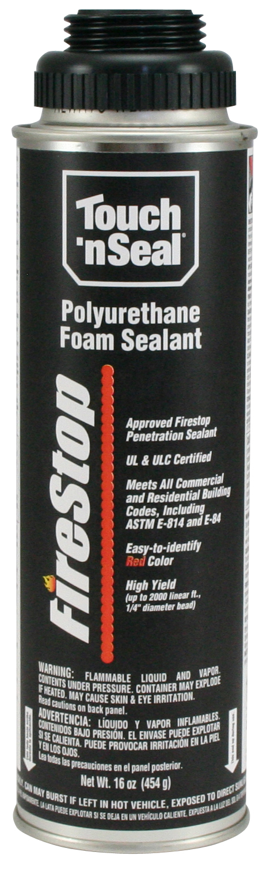
FireStop Gun Foam
Touch ‘n Seal FireStop Gun Foam is the only USA manufactured, one-component foam approved as a through-penetration firestop sealant for both commercial and residential applications. It is also UL classified for use in common fire penetration joint systems.

FireStop Gun Foam provides a permanent insulating and air sealing bond with many building materials, including wood, masonry, insulating foam boards, metal, plastic, and sheetrock. For HVAC, electrical and plumbing applications, FireStop Gun Foam prevents the passage of smoke and fire when it is used to fill the void around pipes and conduits. It can also be used as fireblock material in space connections such as soffits and drop ceilings, partitions and stud walls at ceilings and floors, and in the tops and bottoms of stair stringers.

The permanent seal against air and moisture infiltration that FireStop Gun Foam provides will not shrink or decompose with age. If a fire were to occur, FireStop Gun Foam would prevent the passage of flame, smoke, hot gas, and water from sealed through-penetrations.
FireStop Gun Foam shuts down spread of smoke and flames.

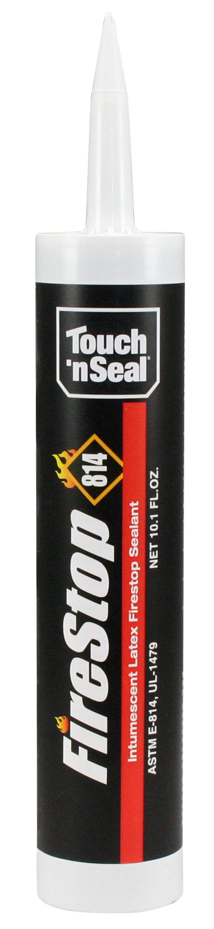
Red in color for easy identification as a fire sealant, FireStop Gun Foam dries within minutes of application. In approximately 30 minutes, it is cuttable if necessary, and depending on ambient temperatures, it’s fully cured in one hour.

FireStop 814 Sealant
Touch ‘n Seal FireStop 814 is a UL classified, one part, elastomeric, intumescent firestop caulk that meets or exceeds the requirements of ASTM E-814 (UL 1479).

FireStop 814 bonds to almost any traditional building surface, including wood, concrete, gypsum board, fiberboard, and metal. When used in wood and concrete assemblies, FireStop 814 is an approved through-penetration sealant for use around HVAC ducting; metal and plastic pipes; electrical and communications wire or other cabling.

Red in color for easy identification as a fire sealant, FireStop 814 Sealant is non-toxic and formulated with non-combustible, inorganic materials. When exposed to high temperatures, FireStop 814 will expand to form an insulating char to stop the spread of fire, smoke and toxic gasses through construction openings.

FireStop 814 will not slump, making it ideal for both horizontal and vertical applications, indoors and out. It is permanent and will not decompose with age. When cured, FireStop 814 can be painted, if desired.
FireStop 814 is a permanent, flexible caulk that expands when exposed to heat.

“It’s important to note that FireStop Gun Foam is ideal for use in combination with FireStop 814 Sealant. Used together, both products meet the requirements for more than a dozen 1 and 2 hour rated Through-Penetration Firestop Systems,” notes Sites.

For more information, visit http://www.touch-n-seal.com or contact Touch ‘n Seal Customer Service at 800-325-6180.

# # #

About Touch ‘n Seal:
Convenience Products, the manufacturer of Touch ‘n Seal products, is headquartered in St. Louis, Missouri. Touch ‘n Seal insulating foams and sealants are the benchmark for performance in commercial and industrial building and maintenance, OEM manufacturing and specialty applications. A full line of one and two-component spray foams and adhesives are available, including fire blocking foam (ICC-ES: ESR-1926), Low Pressure Window & Door Foam, Drywall Panel Adhesives, Heating Systems and Accessories, Two-Component, Disposable Units, Mining Specialty Units and One-Component Disposable Cylinders. Spray foam is available from 15-board feet kits to 120-gallon refill systems. One-component straw and gun foam available in 12 to 30.5 oz. aerosol cans. More information is available at www.touch-n-seal.com, www.facebook.com/TouchNSeal and www.twitter.com/TouchNSeal.

